**Week 5 - Question-Based Review of Lecture**

**September 30, 2022**

Module 1 - Group 1

Module 2 - Group 2

Module 3 - Group 3

Module 4 - Group 2

Module 5 - Group 3

Module 6 - Group 1

# Practice Quiz Questions

**Arrythmia is a term used to describe abnormal rhythm of the heart. Two ways that arrythmia can manifest is as bradycardia or tachycardia. Describe the effects of bradycardia and tachycardia on patterns of heart rhythm. List one possible health outcome and one possible treatment of each.**

When a person has bradycardia, his hear beats fewer times per minute during rest than is expected. Humans’ rest heart beats are usually between 60 and 100 beats per minute, but the heart of a person with bradycardia will usually beat less at less than 60 BBM.

Possible health outcome: It can cause shortness of breath, lighheadedness and possibly make you faint.

Possible health treatment: One possible treatment for bradycardia is the installation of a pace-maker. This device is connected to the nerve centers of the heart and can artificially trigger the contraction of the atriums and ventricles. Since it has a tiny computer inside regulating the beats, it can “force” the heart into a normal rhythm.

A person has tachycardia when his heart beat goes over 100 beats per minute. This is not necessarily a bad thing since most people’s heart beats usually go over a 100 BBM when they exercise, but it can be concerning if this is occurring while at rest.

Possible health outcome: I can cause chest pains and can lead to a stroke if sever tachycardia is left untreated.

Possible health treatment: It is usually treated with medication, but more drastic measures, such as the installation of a pacemaker, can be taken.

**Microevolution occurs as a result of change in allele (genes that vary between individuals) frequency in a population from one generation to the next. List two examples of observed microevolution that have had an effect on human health (positive or negative). Describe how natural selection causes microevolution.**

Natural selection is the process through which populations of organisms transformed and differentiated themselves throughout millions of years of evolution. Organisms are able to survive if they can feed themselves and reproduce. Those individuals whose traits allow them to thrive in their environment are more likely to live longer and produce more offspring than individuals with less advantageous traits.

Since individuals inherit their parents traits (through their genes), with time an increasing percentage of a species population has these “advantageous” traits and a decreasing percentage has the less advantageous traits.

An example of microevolution is the development of pesticide resistant lice. In recent times humans have developed pesticides that kill lice that are present in childrens heads. There were some individuals that had genes that made them resistant to these pesticides, but they were not the entirety of the population. When we started treating the children with pesticides, the lice without resistance dies, but the ones with resistance survived. After a while most lice where resistant to pesticides, and that is the story of how the lice population evolved.

Another example of microevolution, similar to that of lice, is the development of resistance to DDT in the mosquito population in the last century. A chemical called DDT was widely used to kill mosquitos and prevent the spread of malaria all around the world. With time, the originally smaller portion of the mosquito poputlation that had natural resistance against DDT was the only one left. They continue reproducing, since their reproduction was not hindered by the spray of DDT, and went on to become a significant portion of the total mosquito population.

**Define “addiction” and “physiological dependence”. How are these terms similar and different? Discuss the challenges of breaking each.**

Physiological dependence refers to the physical dependence that an individual may have on a certain substance. Addiction, in a sense, is a superset of physiological dependence, where the consumption of the substance becomes the main goal of the individual, and they depend on it metnally and physically.

FILL OUT THE CHALLENGES OF BREAKING EACH

**Bona’s answer:**

Addiction: compulsive use of drugs -> Tolerance/physiological dependence may also be present. It can also be only mental.

Challenges to solve addiction: TALK ABOUT A CHALLENGE THAT IS MENTAL AND NOT NECESSARILY PHYSICAL. Desire to use drug, physiological dependence, financial stuggles, mental health, etc.

Physiological dependence: The actual physiological adaptation of body (cnages in brain / body chemistry) to the drug.

Challenges to solve physiological dependence: Withdrawal, body has trouble functioning without.

**Describe briefly Edward Jenners' 1976 cowpox experiment. What technology was developed as a result of this experiment?**

Jenners took pus from a cow milkmaid with cowpox and inoculated an 8 year old boy with it. Then he injected smallpox into the kid, who did not get smallpox lesions. The technology that was developed was vaccines.

**What were the three legs of the Triangular Trade? In what ways did the institution of slavery and the triangle trade change sugar production and consumption?**

Dawdwad

**What does insulin do? What is insulin resistance?**

What does insulin do? Insulin helps blood sugar enter the body’s cells so it can be used for energy.

What is insulin resistance? When body cells can’t process insulin, so glucose cannot absorb the glucose, which builds up in the arteries.

**What does it mean for an epidemiological study to be biased? What are two types of systematic bias? Provide one example of each.**

It is biased when it is designed in a way that provides an inaccurate outcome. Even if it is executed properly, a biased study will provide misleading results.

Selection bias:

Measurement bias:

**Why is hypertension prevalence greater in developing countries? Discuss one environmental cause.**

People in developing countries are often more prone to hypertension because it is caused by excessive sodium intake and people in such countries generally have a lower income and buy cheaper food products, which are often more processed and have higher added sodium content.

**How is body mass index measured? What is one reason why body mass index is often viewed as an invalid measure of obesity.**

BMI (body mass index) is a measurement of body composition calculated using a ratio of height to weight. It is often considered invalid in diagnosing obesity because it does not take into account muscle mass, bone density, and other factors which are not fatty tissue but may contribute to weight.

**What does an odds ratio measure? What is the odds ratio of olive purchases? Soft drinks? How would you interpret each? Discuss dietary trends present in the graphic and what their expected effect would be on health outcomes.**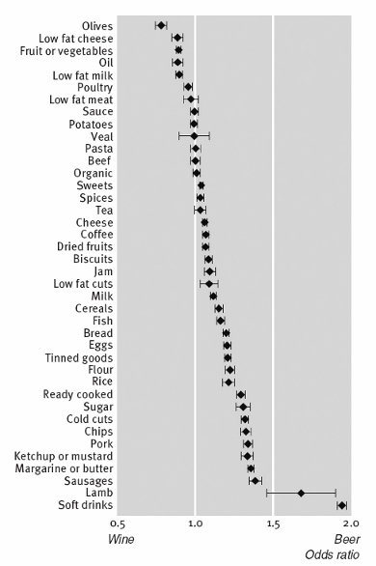

The odds ratio of soft deink purchases

# Previous Midterm Questions

**Question 1 (4 points): Explain evolutionary mismatch and give an example.**

Evolutionary Mismatch is a concept in evolutionary biology that refers to evolved traits that were once advantageous but became maladaptive due to changes in the environment. This can take place in humans and animals and is often attributed to rapid environmental change.

An example of evolutionary mismatch are inflammatory response and unwanted excessive inflammatory response. Humans have developed these responses to preserve each individuals health, but at the time this happened there were certain infectious diseases that didn’t exist, such as COVID-19. Now that it exists, it makes the body overreact and causes excessive inflammation, which is detrimental to our health.

**Question 2.1: Explain natural selection and give an example. (Talk about selective pressure, proliferation of genes and reproductive fitness)**

Natural selection is the process by which through which populations of organisms transformed and differentiated themselves throughout millions of years of evolution. Organisms are able to survive if they can feed themselves and reproduce. Those individuals whose traits allow them to thrive in their environment are more likely to live longer and produce more offspring than individuals with less advantageous traits.

Since individuals inherit their parents traits (through their genes), with time an increasing percentage of a species population has these “advantageous” traits and a decreasing percentage has the less advantageous traits.

An example of short term natural selection is the development of pesticide resistant lice. In recent times humans have developed pesticides that kill lice that are present in childrens heads. There were some individuals that had genes that made them resistant to these pesticides, but they were not the entirety of the population. When we started treating the children with pesticides, the lice without resistance dies, but the ones with resistance survived. After a while most lice where resistant to pesticides, and that is the story of how the lice population evolved.

**Question 2.2 (4 points): What was the most important intervention in reducing infectious outbreaks in cities? Can you give an example of a disease tackled with epidemiology? ( Talk about water pump, zoning epidemiology)**

The growth in scientific knowledge between the 1800s and the 1900s regarding the sources of disease provided people in cities with more information about how to potentially solve the proliferation of diseases.

Water supply and sewage removal: The fecal-oral way of transmission was accepted and understood, and measures were taken to make sure that the water supply never went into contact with feces. Sewer systems were created/improved and water began to be boiled before being consumed.

Monitor community health status: Governments started monitoring the health status of the population and using epidemiological tools to narrow down the causes of disease and eliminate them.

Connection between poverty and disease: The connection was drawn between poverty and the proliferation of diseases. As the quality of life in cities increased (people had more personal space, access to more hygiene resources, etc.), the rate of disease transmission naturally became lower.

It is important to note that infectious diseases in urban areas significantly decreased, even before the invention of antibiotics. Today poverty is still the best single predictor of poor health.

An example of an issue that was tackled with epidemiology is 1854 cholera outbreak in London. Dr. John Snow, who is considered the father of epidemiology, mapped out the cases of cholera that were occurring around a certain point in Broadwick Street. He realized after plotting the outbreaks on a map that they seemed to occur radially around a central location. When he inspected that location, he realized that there was a water pump there whose underground water supply was in contact with disposed human feces, which he thought could be potentially contaminating the water. He took the handle of the pump, forcing the people to get it from elsewhere, and the outbreak subsided.

**Question 3 (4 points): Why are some questions not suitable for a randomized clinical trial? What other options do epidemiologists have?**

* There are cases where researchers are trying to compare the effects of an activity that is believed to be unhealthy (e.g., smoking). In these cases, it would violate ethical guidelines to give people cigarettes. Researches can resort to obervational studies where they look at the behaviours that people already have and what effect they cause in their bodies.
* There are cases where a disease/negative outcome is so rare, that following a lot of peoples daily action until someone gets the disease is not reasonable. In these cases, researches look for information in the opposite way. They find people with the disease they want, and they try to look back and see if a certain behaviour or patter caused it.
* Other things to note:
  + If they want to identify correlations between a behavioural pattern and an outcome (e.g., people that drink tea sleep earlier).
  + Sometimes the weight of pre-existing evidence is so great that a randomized trial is not warranted and regarded as unethical.

**Question 4 (4 points): Describe three differences between Type 1 and Type 2 Diabetes**

1. In Type 1 diabetes, your body is unable to produce insulin because your immune system destroys beta cells in the pancreas. In Type 2, your body still produces insulin, but not enough / inefficiently.
2. Type 1 usually develops in childhood, and Type 2 is most commonly developed in adults over 45 (although can be discovered at any age for both)
3. There are no known prevention methods for Type 1 diabetes, whereas preventative measures such as a healthy lifestyle can be taken against Type 2 diabetes.

**Question 5 (4 points): Is obesity a choice? Why or why not? (Talk about calorie in, calorie out, genetic and environmental factors)**

Obesity is not necessarily a product of lifestyle choices. Although weight loss can be determined by calories-in-calories-out (and accomplished through a combination of exercise and diet), it is not very useful to think of obesity in terms of the First Law of Thermodynamics. Doing so ignores the genetic components and external factors that are uncontrollable and influence obesity.

1. Genetic causes, such as Prader Willi syndrome
2. Medical causes, such as a stroke to the hypothalamus
3. Environmental causes, such as socioeconomic class, drugs, breast feeding, endocrine disorders, social networks, night eating, gas prices

# Module 1 - Group 1

**Describe, briefly, how blood flows to, from, and through the heart.**

The carbon dioxide-heavy blood that reaches the heart after its oxygen has been depleted flows into the right atrium. From there it is let into the right ventricle, that pumps it to the lungs, where it is oxygenated. It returns to the heart and enters the left atriums. A valve then lets the valve flow to the left ventricle, that pumps it once again, but these time to all the rest of the body’s tissues. And the cycle repeats itself.

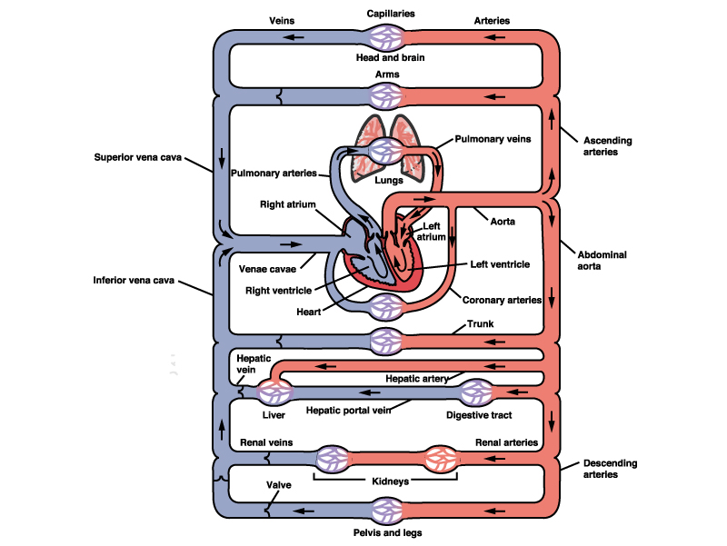

**What are the main cardiovascular diseases and their effects on individuals and society?**

awda

**What are the mechanisms by which chronic inflammation leads to atherosclerosis?**

dwad

**What is the purpose and benefit of a pacemaker?**

dd

**Is CVD incidence/mortality better or worse than in the past?**

dawd

# Module 2 - Group 2

**What molecules played an essential role in the beginning of life on Earth?**

Awdawd

**Define and provide 2 examples of evolutionary mismatch.**

awdawd

**How do natural selection and differential reproductive success lead to evolution?**

dawd

**What is the difference between micro- and macro-evolution?**

dawd

**How does antibiotic resistance develop and how is this related to the concept of evolution?**

awdawd

# Module 3 - Group 3

**What population processes are explained by the demographic transition, and the epidemiological transition?**

The demographic transition model describes how the population growth rate changes as a country moves from a pre-industrial to industrialized economy. The epidemiological transition model describes the rise and fall of diseases as societies develop.

**What are the stages of the epidemiological transition, including the more recent extensions? How does this relate to cardiovascular disease?**

Stage 1, or the stage of pestilence and famine, is the stage in which infectious and parasitic diseases are the main cause of human deaths. Stage 2, or the stage of receding pandemics, occurs when the pandemics of stage 1 recede. Stage 3, or the stage of degenerative and human-created diseases, occurs when chronic disorders associated with aging begins to replace infectious diseases as the main cause of human deaths. Cardiovascular diseases begin to be a more common cause of death in stage 3. In Stage 4, or the stage of delayed degenerative diseases, the major degenerative causes of death (e.g., heart disease) remain, but life expectancy is extended through medical advances. A possible 5th stage is known as the stage of reemergence of infectious and parasitic diseases (from stage 1). Some medical analysts argue that the world is entering a fifth stage given the reemergence of diseases thought to have been eradicated, such as polio and monkeypox, as well as the emergence of new diseases like Covid-19.

**Do all countries and populations follow these theoretical transitions in a linear, time-stamped way?**

No, some countries and populations move through the stages of the epidemiological transition model at different rates, depending on when they undergo development. For example, countries that have industrialized within the last 50 years, such as South Korea, have moved through stages 3 and 4 much more quickly than countries that developed earlier, such as the United States.

**How has the demographic and epidemiological transition aided in understanding developing countries' current public health and policy goals?**

# Module 4 - Group 2

**How does smoking cigarettes affect the brain?**

Awd

**How is tobacco an example of evolutionary mismatch?**

Awd

**What are 3 examples of policies implemented by countries to reduce the health impacts of smoking on their populations?**

Awdw

**What were the main findings in the Swedish Twin study?**

Awdwad

**What is the difference between physiological dependence, addiction, and tolerance?**

awdwad

# Module 5 - Group 3

**What were the three legs of the Triangular Trade?**

Awdwad

**Briefly describe the three stages of acquisition of enslaved people, the middle passage, and arrival in the New World.**

Awdawd

**In what ways did the institution of slavery and the triangle trade change sugar production and consumption?**

awdwa

# Module 6 - Group 1

**Provide an overview of the obesogenic environment model, energy balance model, and the carbohydrate-insulin model.**

Dwad

**What are different genetic factors that can lead to obesity?**

Dawd

**What are different environmental factors that can lead to obesity?**

Awdw

**List 2 "obesity myths" and whether they are based in fact or have been debunked.**

dawd